### Fruit Finder

Ethan Russell, Scott Cai

Rose-Hulman Institute of Technology

CSSE-463 Image Recognition

Email: [russelec@rose-hulman.edu](mailto:russelec@rose-hulman.edu), [cais1@rose-hulman.edu](mailto:cais1@rose-hulman.edu)

#### Abstract

Simple images can be classified using thresholds of color and post processing. We developed an algorithm to find specific fruit within pictures containing mixed fruit on relatively simple backgrounds. This algorithm characterizes the pixels based on hue, saturation, and value thresholds set through quantitative analysis and adjustment. Then, the algorithm rejects some clusters of pixels that are too small to be fruit, and performs morphological operations to smooth the fruit images. The algorithm performs very well on images with a clear background and fruit that do not overlap. It achieves 100% accuracy on each of the three test images. However, the algorithm degrades when there is excessive overlap of fruit – it cannot very well distinguish neighboring fruit.

**Ideas for Improvement**

Our algorithm struggled with overlapping fruit images. We think the algorithm could be improved through the use of edge-detection. For example, creating a black space in the mask at all of the edges at the very end of post processing would separate fruit that have merged together through the post processing. Our algorithm also struggled with fruits where parts of it were a different color. For example, the apples tended to have very large reflections on them that did not look like apples to our algorithm. We could introduce an apple-reflection threshold to our filter – if there are pixels that are close to white very near some red pixels, they should be considered part of the apple. We could do the same operation for the brown spots on bananas.

Mixed_fruit1 apples:

|  |  |  |  |
| --- | --- | --- | --- |
| Apple Number | Size | Centroid Row | Centroid Column |
| 1 | 6361 | 358.16 | 117.05 |
| 2 | 3812 | 363.44 | 211.7 |
| 3 | 3056 | 426.01 | 144.58 |
| 4 | 2242 | 440.02 | 228.07 |
| 5 | 4769 | 500.4 | 166.59 |
| 6 | 4635 | 514.35 | 263.71 |

mixed_fruit2 Oranges

**1. Introduction**

We are attempting to find and count different types of fruit within color images. Specifically, the fruit we focused on are apples (only red), oranges, and bananas. This may seem trivial – a simple color filter to separate red, orange, and yellow should suffice. However, this is not nearly so simple. The fruits vary in color and shading enough that there is significant overlap in the colors. For example, an orange with an under-ripe portion may look quite yellow, like a banana. On the other hand, an apple that is too dark and in the shade may not even look like a fruit to that algorithm. We have created an algorithm that can find most fruits accurately under various circumstances. For our algorithm to function as intended the image must have a background that does not match the fruit color. Our algorithm can accommodate a wide array of lighting conditions, but struggles to identify multiple fruit of the same type that are touching.

**2. PREpROCESSing**

The first step of our fruit finder is to filter based on the pixel characteristics. To establish these metrics, we would need to do quantitative analysis of the colors of the fruit. We started by examining the RGB color values of each of the fruit using photos taken under daylight and fluorescent lighting conditions. We found that RGB would be very difficult to come up with reliable metrics. For example, to define an “apple” color range, there would need to be a range of red values, a different range of green values, and yet another range of blue values. These ranges would define a 3D “cube” of color that encompasses many colors, not all of which would be red. Coming up with RGB ranges in this way would yield too wide of a range of colors and would not be appropriate for separating fruit. Instead of using the RGB color space, we chose to use HSV for our color filtering. This would give us a single range for the hue, then separate ranges for saturation and value. This would be much easier to specify the colors of our fruit. We started by converting the images to the HSV using MATLAB’s built-in rgb2hsv function. We plotted the hue, saturation, and value histograms of the day and fluorescent images for each of the three fruit types.

**2.1 Apples**

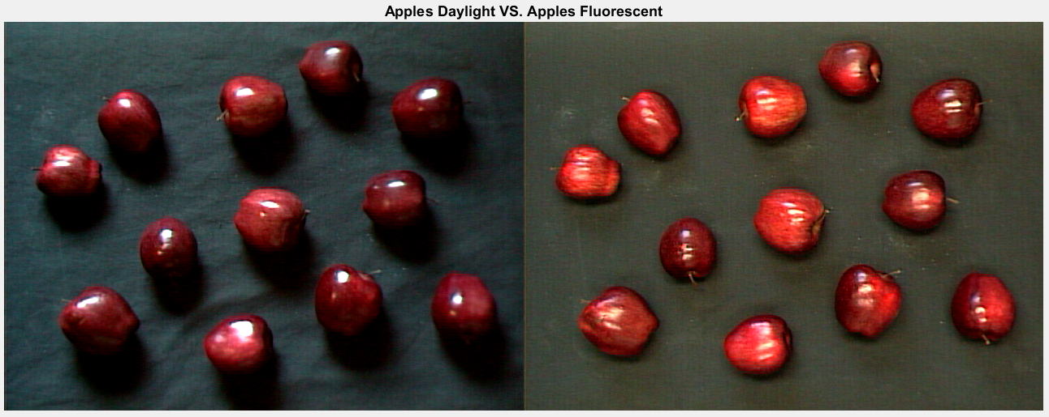

*Figure 1: This compares the images for apples in the daylight (left plot) and in fluorescent light (right plot)*



*Figure 2: This shows the histogram of the hue values for 'apples_day.tiff' (top plot) and ‘apples_fluor.tiff’ (bottom plot)*

Since we know the apples are red, we are only interested in the hues from 0 to 0.1, and from 0.9 to 1, roughly. This matches our apple hue histogram in Figure 2, where there are peaks at 0 and 1. We can assume that anything outside that range is not an apple, and therefore can be ignored for our apple filter. For the histograms for the saturation and value, we only examine the saturation and value data corresponding to hues < 0.1 or >0.9.



*Figure 3: This shows the histogram of the saturations after applying the rough hue filter for 'apples_day.tiff' (top plot) and ‘apples_fluor.tiff’ (bottom plot)*

From Figure 2, we can see that the saturation depends largely on the lighting. However, in both histograms, there are more saturation values between 0.5 and 1. We speculate that saturations below this value may be background pixels that were not removed by our preliminary filter. We will move on to use a lower saturation cutoff of 0.5 for our initial filter design.



*Figure 4: This shows the histogram of the values after applying the rough hue filter for 'apples_day.tiff' (top plot) and ‘apples_fluor.tiff’ (bottom plot)*

From Figure 3, we can gather that for apples, the value is very much dependent on the lighting of the picture, so we must accommodate a wide range of values with our filter. From these graphs, we chose to accept values greater than or equal to 0.05. Also examining the photos of the apples in Figure 1, we can see the apples can get very dark, which supports the decision to set a relatively low value cutoff for apples.

**2.2 Bananas**

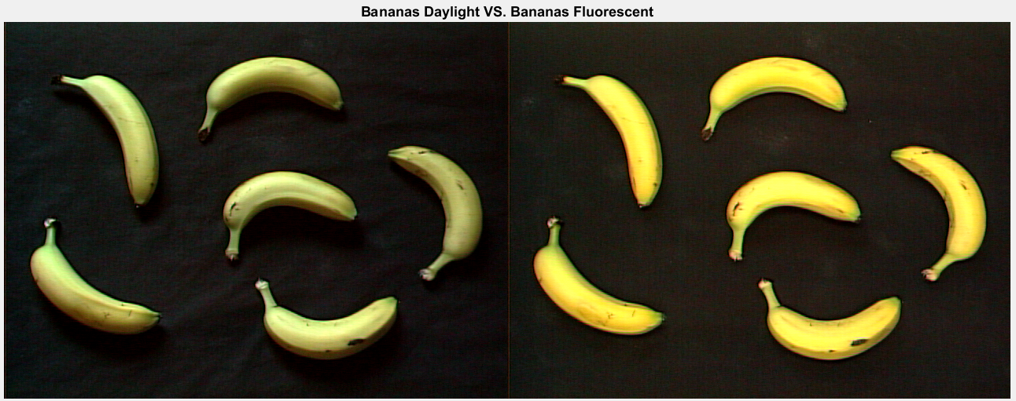

*Figure 5: This compares the images for bananas in the daylight (left plot) and in fluorescent light (right plot)*



*Figure 6: This shows the histogram of the hue values for 'bananas_day.tiff' (top plot) and ‘bananas_fluor.tiff’ (bottom plot)*

From Figure 6, we can interpret that the banana’s hues are not very distinct from the background image. We can estimate the hue of the bananas is between 0.1 to 0.3, because that is the general range for yellow. For the saturation and value histograms, we only examined pixels with hue between 0.1 and 0.3.



*Figure 7: This shows the histogram of the saturations after applying the rough hue filter for 'bananas_day.tiff' (top plot) and ‘bananas_fluor.tiff’ (bottom plot)*

From Figure 7, we can tell that these pixels follow a fairly normal distribution for saturation. We can choose an initial saturation lower cutoff of 0.4.



*Figure 8: This shows the histogram of the values after applying the rough hue filter for 'bananas_day.tiff' (top plot) and ‘bananas_fluor.tiff’ (bottom plot)*

From Figure 8, we can see there is a large peak in value at roughly 0.1. We can assume that this peak is caused by background pixels, because the bananas are much lighter in color than the background. We wish to reject this background peak, so we chose an initial lower value cutoff of 0.25.

**2.3 Oranges**

Oranges 0-0.15

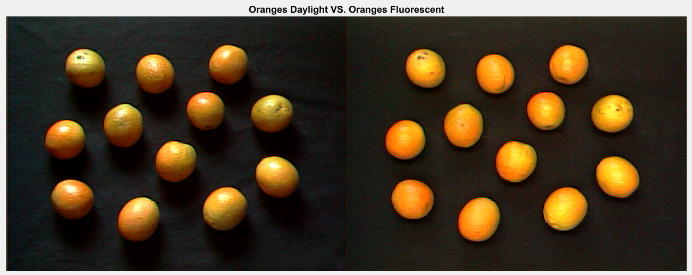

*Figure 9: This compares the images for oranges in the daylight (left plot) and in fluorescent light (right plot)*



*Figure 10: This shows the histogram of the hue values for 'oranges_day.tiff' (top plot) and ‘oranges_fluor.tiff’ (bottom plot)*

From Figure 10, we can see that there is a peak in hue from 0 to 0.15, which corresponds roughly with the color orange. We will filter based on this range of hues. The histograms for saturation and value only examine pixels with hues in that range.



*Figure 11: This shows the histogram of the saturations after applying the rough hue filter for 'oranges_day.tiff' (top plot) and ‘oranges_fluor.tiff’ (bottom plot)*

From Figure 11 we can see that the saturation has a peak from 0.7 to 1. There is also a raised section from 0.3 to 0.5, but this is fairly low saturation and could be due to the background pixels which were not filtered out by the preliminary filter. We will choose an initial lower saturation cutoff of 0.5 for the oranges.



*Figure 12: This shows the histogram of the values after applying the rough hue filter for 'oranges_day.tiff' (top plot) and ‘oranges_fluor.tiff’ (bottom plot)*

Finally, Figure 12 shows a large peak in value between 0 and 0.2, which may be attributed to the background pixels which were not removed by the preliminary filter. We will choose an initial lower value limit of 0.3 in attempt to reject background pixels.

**3. HSV Filters**

After collecting and analyzing the HSV histograms for the fruit, we created a filter based on the rough values we found. This initial filter can be found in table 1.

*Table 1: This shows the thresholds we define for the initial fruit HSV filter*

|  |  |  |  |
| --- | --- | --- | --- |
|  | Hue | Saturation | Value |
| Apple | H<=0.1 or H>=0.9 | S>=0.5 | V>=0.05 |
| Orange | 0<=H<=0.15 | S>=0.5 | V>=0.3 |
| Banana | 0.1<=H<=0.3 | S>=0.4 | V>=0.25 |

Using these initial filter values, we created an RGB mask to specify where the pixels are that made it through each filter. Red pixels correspond with apples, green pixels correspond with oranges, and blue pixels correspond with bananas.

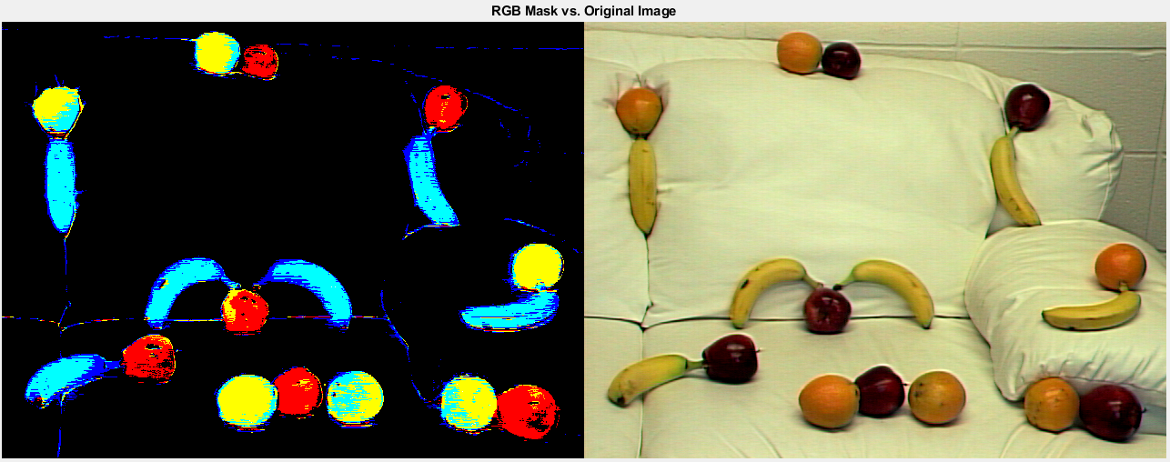

*Figure 13: Left: RGB mask using the initial filter values in Table 1. Right: original image, mixed_fruit2.tiff. See additional images and masks in Appendix A.*

From Figure 13, it is apparent that our thresholds need some work. For example, if we look at the bananas, they contain many cyan pixels, meaning the filter determined that those pixels are both bananas and oranges. Knowing this, we adjusted the hue of orange and banana so there would not be overlap. We adjusted all of the color ranges in this way, and came upon the final hue limits shown in Table 2. Similarly, we adjusted the value and saturation limits so that the masks would display as much of the fruit as possible without introducing any additional background pixels. The final value and saturation limits we chose to use can be found in Table 2.

*Table 2: This shows the thresholds we define for the final fruit HSV filter*

|  |  |  |  |
| --- | --- | --- | --- |
|  | Hue | Saturation | Value |
| Apple | H<=0.06 or H>=0.89 | S>=0.5 | V>=0.05 |
| Orange | 0.06<=H<=0.115 | S>=0.4 | V>=0.25 |
| Banana | 0.125<=H<=0.25 | S>=0.5 | V>=0.25 |

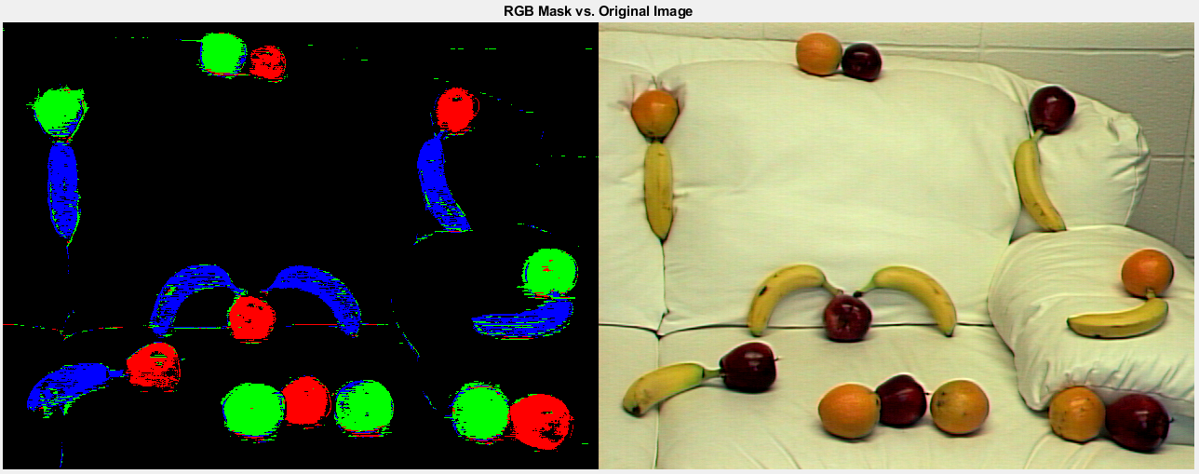

*Figure 14: Left: RGB mask using the final filter values in Table 2. Right: original image, mixed_fruit2.tiff. See additional images and masks in Appendix B.*

Figure 14 shows the performance of the final filter. All the fruit are masked with their respective color aside from a few stray pixels. There are also very small clusters of background pixels which remain. However, these are small enough that they can be removed via post-processing.

**4. POST-Processing**

**5. conclusions**

### Appendix A







### Appendix B







applecentroids =

7×2 table

Area Centroid

____ ________________

343 93.606 143.41

333 131.74 48.249

229 196.72 208.47

444 247.12 185.58

334 332.69 217.9

308 447.26 60.357

239 478.68 65.126

orangecentroids =

6×2 table

Area Centroid

____ ________________

620 65.103 143.95

637 274.32 188.8

640 281.81 233.02

441 378.13 53.515

1201 427.18 201.16

565 567.79 180.3

bananacentroids =

6×2 table

Area Centroid

____ ________________

633 161.14 218.95

540 231.82 53.931

617 274.73 56.19

566 388.96 244.03

911 496.5 278.42

498 601.47 188.07

applecentroids =

6×2 table

Area Centroid

____ ________________

1892 161.1 369.41

1847 267.57 319.07

1030 285.61 43.923

1993 325.67 406.96

1485 486.39 94.601

2888 576.87 428.07

orangecentroids =

6×2 table

Area Centroid

____ ________________

1902 59.955 93.38

1723 236.37 33.285

3066 269.62 416.04

2691 389.18 413.86

2950 513.78 418.2

2427 587.18 269.31

bananacentroids =

6×2 table

Area Centroid

____ ________________

2572 72.874 388.83

2729 65.215 178.33

2592 198.09 290.1

2806 343.99 290.9

2693 468.28 175.49

2478 562.84 320.63

applecentroids =

8×2 table

Area Centroid

____ ________________

5691 36.995 299.33

5613 148.33 420.09

3825 163.29 287.97

3962 185.75 175.45

6255 345.2 381.05

2488 462.27 176.03

2796 471.88 305.62

4576 543.56 384.09

orangecentroids =

7×2 table

Area Centroid

____ ________________

5518 52.355 167.25

2182 138.43 210.75

6070 189.63 360.48

5147 281.45 180.09

4376 303.94 319.94

5229 426.98 246.75

6005 454.81 364.66

bananacentroids =

6×2 table

Area Centroid

____ ________________

5513 101.81 230.15

4949 257.61 241.35

4069 249.08 96.583

5492 388.99 160.12

4835 492.11 63.312

6630 571.59 237.24

applecentroids =

6×2 table

Area Centroid

____ ________________

6361 358.16 117.05

3812 363.44 211.7

3056 426.01 144.58

2242 440.02 228.07

4769 500.4 166.59

4635 514.35 263.71

orangecentroids =

1×2 table

Area Centroid

_____ ________________

51191 194.14 193.87

bananacentroids =

1×2 table

Area Centroid

_____ ________________

29365 354.16 334.43